Selected Works
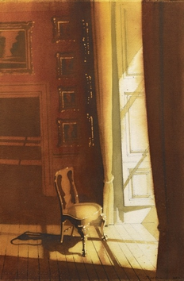 | Hugh Buchanan  Light on Picture Frames, 2021  Watercolour  Paper 54 x 36 cm  Framed 75 x 55 cm | £ 6,000.00
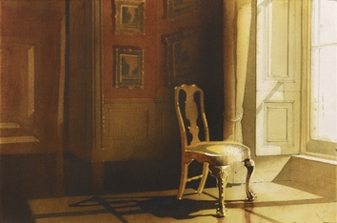 | Hugh Buchanan  View to a Gallery, 2021  Watercolour  38 x 58.8 cm | £ 6,000.00
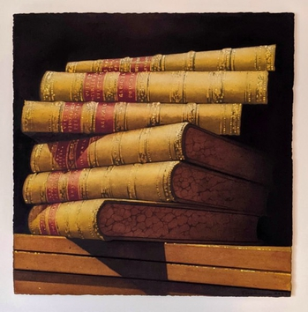 | Hugh Buchanan  The Lives of Painters, 2022  Watercolour  50.8 x 50.8 cm | £ 6,000.00
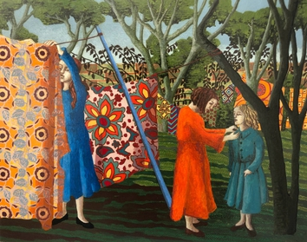 | Kate Montgomery  Sister's Blue Dress, 2023  Oil on board  30 x 37 cm | £ 2,400.00
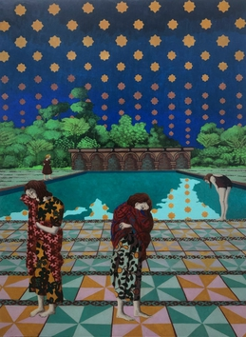 | Kate Montgomery  The Heavens' Embroidered Cloths, 2024  Casein on Birch Panel  60 x 47 cm | £ 3,800.00
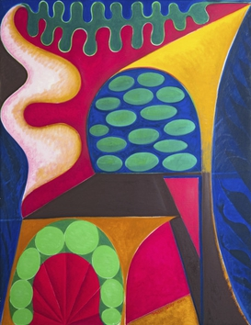 | Maro Gorky  Late Spring, 2014  oil on canvas  130 x 100 cm | £ 24,000.00
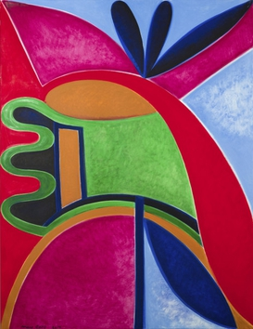 | Maro Gorky  Spring, 2014  oil on canvas  130 x 100 cm | £ 24,000.00
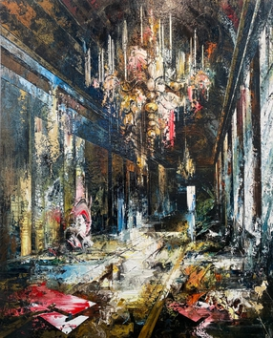 | John Monks  Sound, 2024  oil on canvas  214 x 171 cm | £ 67,000.00
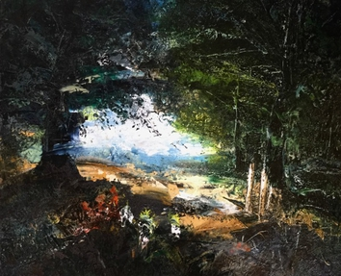 | John Monks  Landscape, 2024  oil on canvas  76 x 94 cm | £ 25,000.00
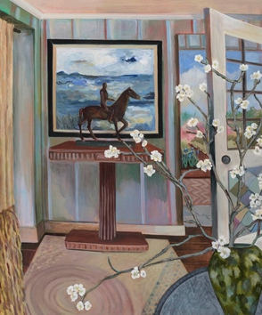 | Lottie Cole  Loveliest of all the Trees, 2023  oil on canvas  120 x 100 cm | £ 6,200.00
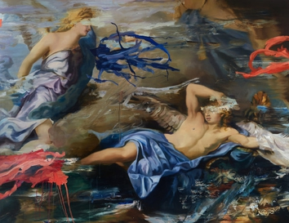 | Simon Casson  Aventine, 2023  oil on canvas  140 x 180cm | £ 20,350.00
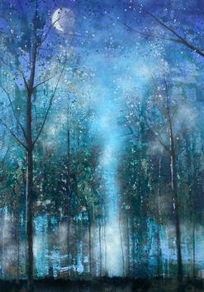 | Nick Archer  Moon Forest, 2023  oil on canvas  120 x 85 cm | £ 6,300.00

