Nuits Blanches

Kate Montgomery

Private view

Wednesday 25 June 2025, 6 – 8 pm

Exhibition

25 June – 25 July 2025

*Night Painter*, 2025

*Night Painter celebrates the reflective nature of painting at night and the creative working reality of being an artist-mother.*

Long & Ryle are delighted to announce the forthcoming solo exhibition by Kate Montgomery *Nuits Blanches.* This will be Kate Montgomery’s third solo exhibition with Long and Ryle.

Nuits Blanches (Sleepless Nights) connects Montgomery’s nighttime paintings with the imagery of domestic life. Her atmospheric paintings convey the fading light of the day, or the magic of starlit parks and gardens. Figures, mainly women are set in tableaus against the patterns Montgomery includes as theatricals backdrops. A stage or perhaps a room become the settings, nature competes so the viewer is uncertain if the scene is set outside or within an interior. The suggestion of interior spaces is associated with female responsibility, creativity and desire set by Montgomery in silent houses.

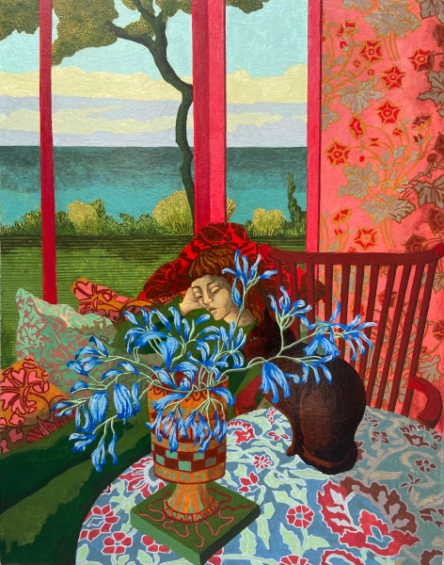

*Asleep in the Ocean,* 2024

Kate Montgomery’s interest in textiles, and her studies in pattern, whether inspired by Victorian wallpapers or Islamic tiles, form the texture and aesthetic of her painting, where patterns and textiles are very much part of the story. She uses geometric principles and Victorian designs to weave through her works, which are small and intensely painted in casein on board. Pattern Book, the title of Kate’s last exhibition with Long and Ryle in 2023 referred to the well-thumbed collection of pattern design books piled up on her studio floor.  From Owen Jones' Grammar of Ornament, Eugene Grasset's La Plante et Ses Applications Ornementales to early modern designers Enid Marx and Margaret Calkin James. Versions of these patterned worlds of stylised plant forms and codified people find their way into her paintings through gardens, textiles and wallpapers. The visual pleasure of colour and pattern is employed to balance the narratives and human drama in Kate Montgomery’s jewel like paintings. Kate’s imagery is developed through compulsive sketchbook drawing on trains, in stations, and within the landscapes and gardens of Kent and Sussex.

Montgomery's paintings are a look behind the curtains, private moments and domestic quiet. The narrative can be solitary, dreamlike or thoughtful, the subject is often an exploration of personal narratives or inspired by the lives of Kate's own daughters. Although as exquisitely rendered as a Flemish Book of Hours, Montgomery’s figures have a newfound monumentality and convey a profound sense of longing. Montgomery is an important artist, her works may be as exquisitely rendered as a Flemish Book of Hours but stepping in the footsteps of Paula Reno, Louise Bourgeois and Shane Rhys James, she quietly conveys the longings and desires of women.

*Night Gate*, 2025

*Night Gate can be interpreted as women and children readying for an all-night city festival, a Nuit Blanche or Les Allumées preluded by a fiery sunset.*

Kate Montgomery studied at The Ruskin School of Drawing & Fine Art, University of Oxford (1985 -88) and at The Royal College of Art, London (1990 – 1992) under Professor Keith Critchlow. Kate Montgomery has been a lecturer at Central St Martins. She is now a tutor at The Royal Drawing School. She was artist in residence at Glynebourne Opera House in 2008. Her work is regularly selected for the RA Summer Show and The Discerning Eye.

Her work is in the collections of Vivien Duffield, Elizabeth Esteve-Coll, HRH King Charles, The Cromwell Hospital London, St John’s College Oxford, New Hall Women’s Art Collection and Murray Edwards College, Cambridge.

Please contact Sarah Long or Romy Dawson for further images and information.

LONG & RYLE

4 John Islip Street, London SW1P 4PX

gallery@long-and-ryle.com

Tel: +44 (0) 20 7834 1434